TicketPK1: "Clear search history" button is not showing below the search bar.  
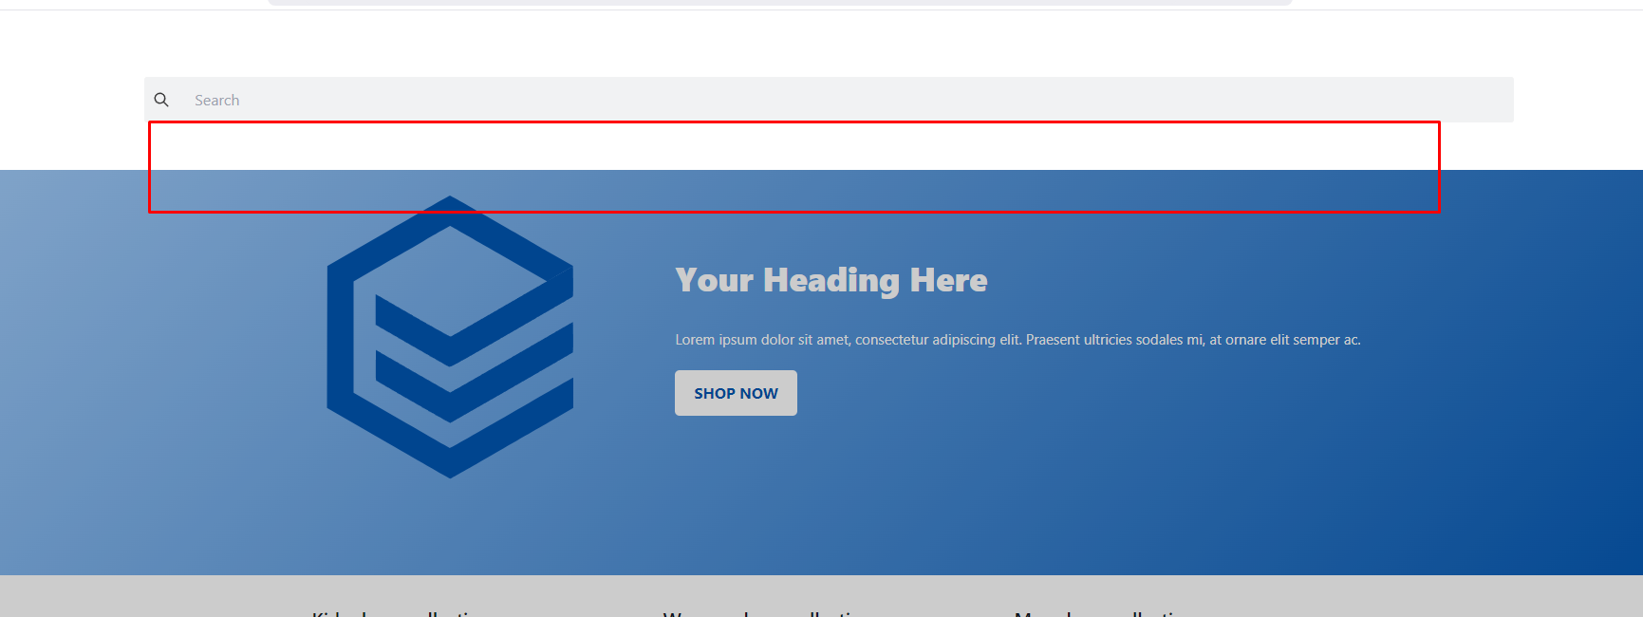

TicketPK2: Previous data is not showing below the search bar

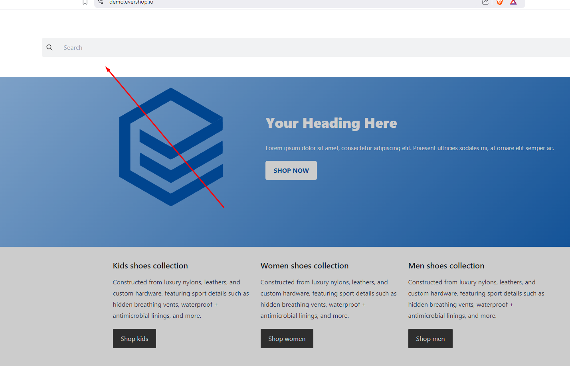

TicketPK3: The product is not showing when the user searches the product category name  
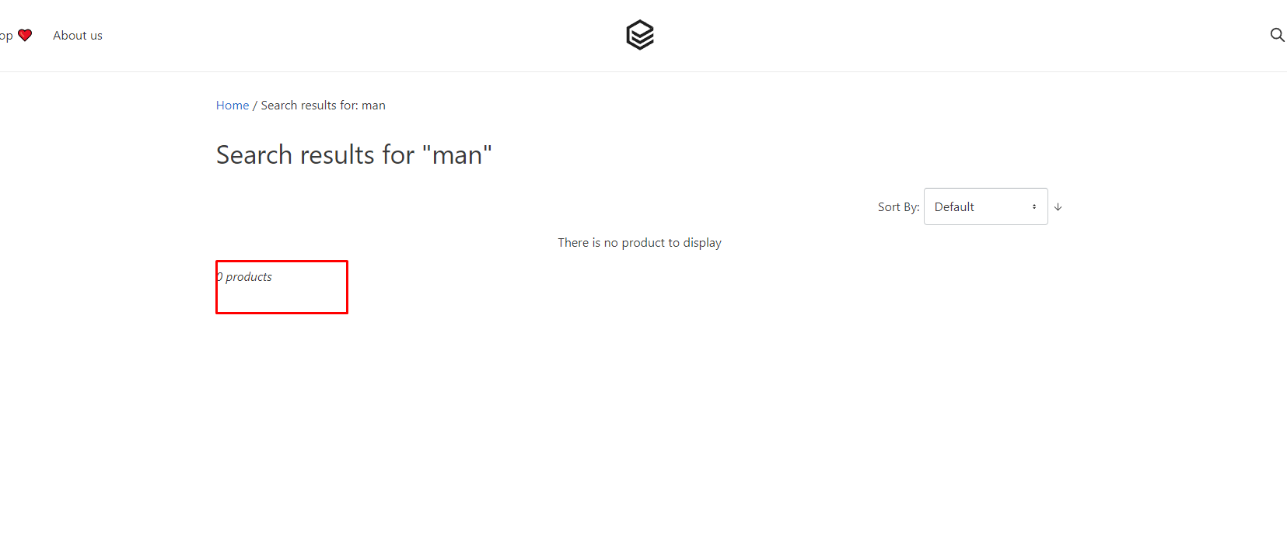

TicketPK4: Similar products are not showing below the search bar

